Canford Cricket Quiz 2020

We hope you will want to try your knowledge / practise your research skills by having a go at the Canford ‘Lockdown’ Cricket Quiz. Please email answers to events@canford.com by Monday 1st June. There will be prizes for the Winner and Runner up.

1st XI – History of the Game

1) Which present England cricket international was born in Christchurch, New Zealand, before moving to England at the age of 12?
2) Which legendary bowler had the nickname 'Whispering Death'?
3) Who became the highest wicket-taker in Test cricket when he overtook Shane Warne's record on 3 December 2007?
4) Which Australian media tycoon is best known for founding the break away World Series Cricket between 1977 and 1979?
5) Which small village in rural Hampshire is known as the 'Cradle of Cricket' and was England's leading cricket club before the formation of the MCC?
6) The Oval is the home ground of which county cricket club?
7) In 1992, at the age of 19, who became the first overseas-born player to represent Yorkshire?
8) How wide is the cricket wicket formed by Cricket the three wooden stumps?
9) Who was the first player to reach 10,000 Test runs?
10) Which South African was chosen as the Wisden Cricketer of the Year in 2003?
11) Which cricketer, with the nickname 'punter', is the only player in the history of Test cricket to be a part of 100 Test match wins?

2nd XI – Name the Badges of the County and International Teams

12) 13) 14) 15)

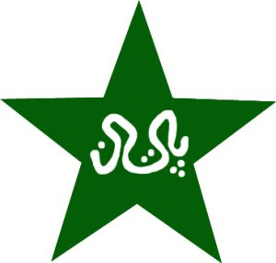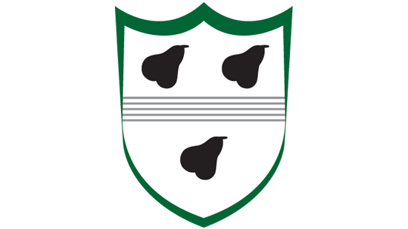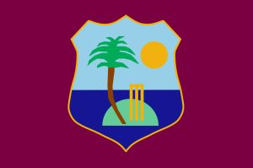

16) 17) 18) 19)

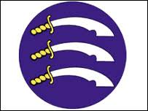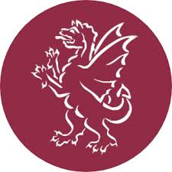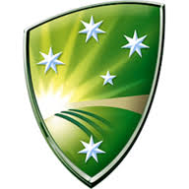

20) 21) 22)
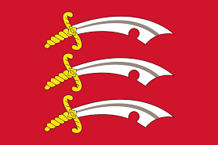

3rd XI (with a 12th Man!!) – Name the 12 Umpire Signals

23) 24) 25) 26) 27) 28)
29) 30) 31) 32) 33) 34)

4th XI – Cricket World Cups

35) Who was the thrower for the winning run out in the super over in England’s Men’s 2019 CWC win?

36) What year was the first Women’s Cricket World Cup held?

37) Who were the 1st winner’s of the Men’s Cricket World Cup?

38) How many runs did England Men score in their winning super over in 2019?

39) Who took 6/46 in England Women’s World Cup Final victory in 2017?

40) Which country has won the most Men’s Cricket World Cups?

41) Which non-test playing team reached the Men’s CWC semi-finals in 2003?

42) Who was England Men’s captain in their winning 2019 team?

43) Which team has played in 4 Men’s CWC Semi-Finals without ever making the final?

44) Who has taken the most wicket’s in Men’s Cricket World Cups?

45) Which England player was the top run scorer in the 2017 Women’s World Cup?

Post Match Teas – Name the 5 Fielding Positions

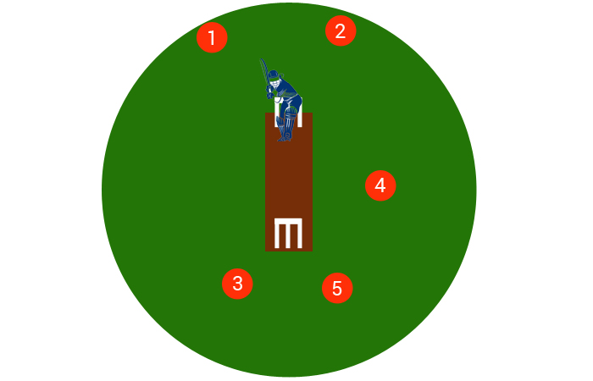

46) – Fielding Position 1

47) – Fielding Position 2

48) – Fielding Position 3

49) – Fielding Position 4

50) – Fielding Position 5

Super Over – Spot the Ball (Tiebreaker if needed!) – Pick One Square

